**Web Traffic Forecasting**

**Report-1**

**Table of Contents**

1. Business Problem 2
2. Business Objective 2
3. Data Acquisition 2
4. Exploratory Data Analysis (EDA) 2

4.1 Missing Values Treatment 2

4.2 DataFrame Transforming 3

4.3 Selected Columns Exploration 3

1. **Business Problem**

The field of time series encapsulates many different problems, ranging from analysis and inference to classification and forecast. There are real-world problems out there corresponding to sequential or temporal observations. By utilizing time series data, we do can help predict future views and answer questions from financial market, pandemic spreading, climate change, et al. Here, we want to forecast the future web traffic. Sites could utilize the forecasting to determine if their sites are popular and if there are any apparent trends, such as one specific page being viewed mostly by people in a particular country. The web traffic forecasting is able to help structure sites, highlight security problems or indicate a potential lack of bandwidth.

1. **Business Objective**

The primary objective of this project is to build a machine learning model to predict the future web traffic. Relying on the previous records, time series analysis will be performed to deliver the most accurate machine learning model. It will ensure that sites are capable to apply the prediction to determine if their sites are popular and if there are any apparent trends, in the meantime to adjust their marketing strategies.

1. **Data Acquisition**

There are 6 datasets from the original data source: the first two train_1 and train_2 are the two main datasets with approximately 145k time series. Each of these time series represent a number of daily views of a different Wikipedia article, starting from July 1st, 2015 up until December 31st, 2016. Each row of these csv files corresponds to a particular article and each column correspond to a particular date. Key_1 and key_2 dataset give the mapping between the page names and the shortened Id column. And sample_1_submission and sample_2_submission are submission files showing the correct format.

The original data is available on <https://www.kaggle.com/c/web-traffic-time-series-forecasting>

1. **Exploratory Data Analysis (EDA)**

In this section, the main dataset will be analyzed with multiple visualization methods and their main characteristics will be summarized.

* 1. *Missing Values Treatment*

One of the most common problems faced in Data Cleaning/Exploratory Analysis is handling the missing values. There are several causes of missing values: sometimes values are missing because they do not exist, or because of improper collection of data or poor data entry. In that case, various filling strategies are required to operate for different situations. Here, since there is impossible for web traffic to be 0, unless unexpected situations, median number of each specific website is used to filling in missing values in this project.

* 1. *Dataframe Transformation*

In order to meet the requirement of Prophet model for machine learning, dataframe is melt to keep only two columns: ‘ds’ for date and ‘y’ for visits.

* 1. *Selected Columns Exploration*

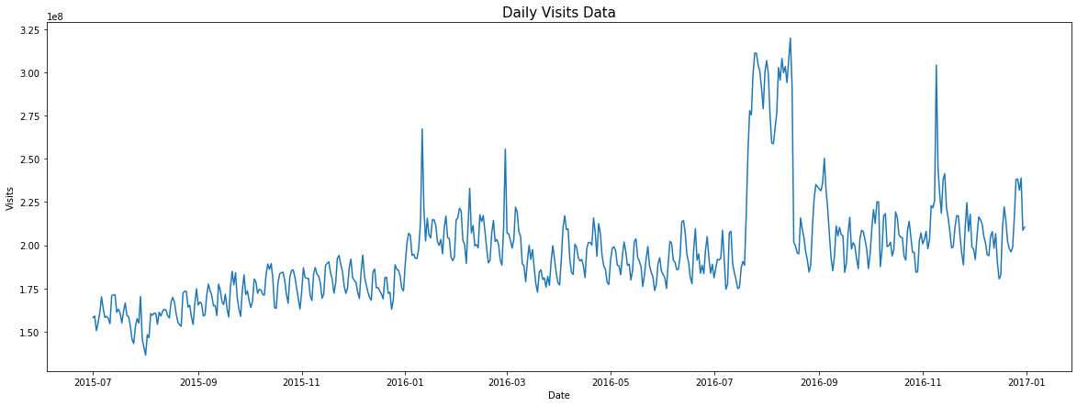

Fig 1. Daily Visits Data

It is clear to observe from figure 1 that there is huge spike around 2016-08, and several medium spikes during year 2016.

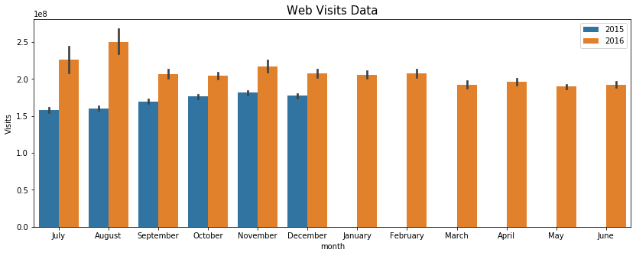

Fig 2. Web Visits Data Yearly Comparison

When look into the yearly comparison of web visits shown in Figure 2, there are spikes showing up in July and August in 2016; while in the latter half of 2015, there are more traffic in November. The whole year of 2016 has more visits than 2015.

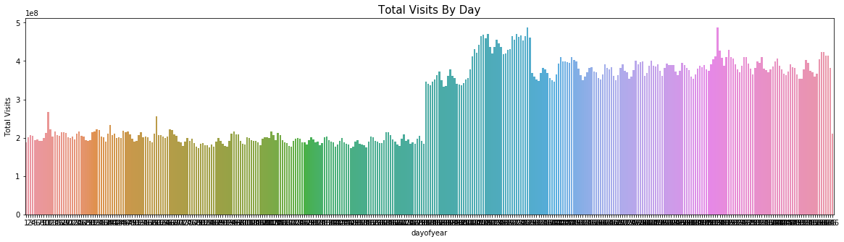

Fig 3. Daily Visits of Year

From figure 3, there is a higher plateau in year 2016 compared to year 2015 and more visits shown up in the middle of 2016.

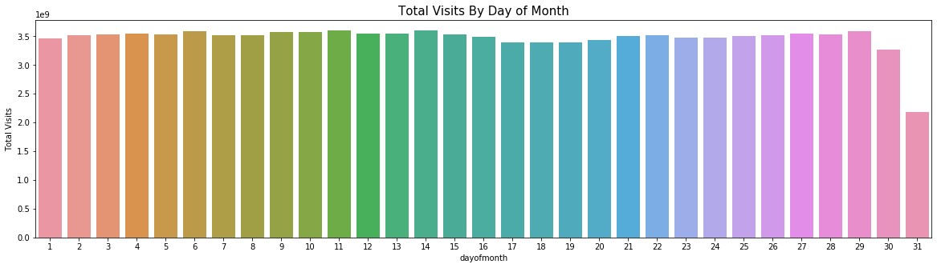

Fig 4. Day of Month Visits

The trend of visits on each day of month exhibited in figure 4. There is slightly more visits at the beginning of each month, while less visits displayed at the end of month.

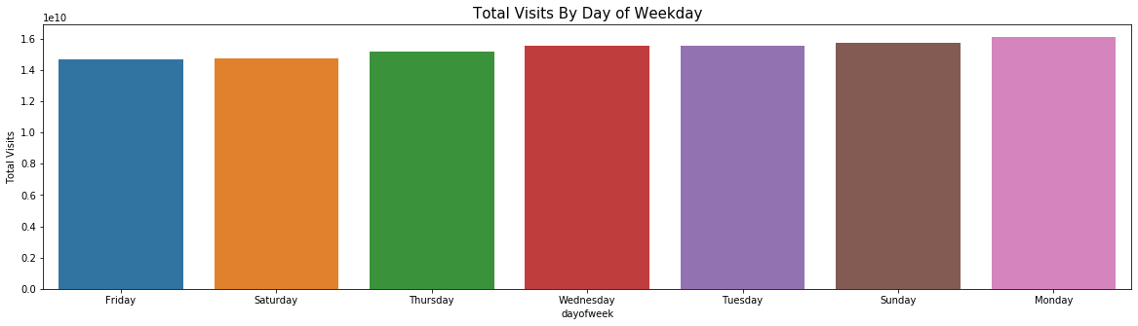

Fig 5. Weekday Visits

According to weekday visits trend, there are similar visits during a week. Monday is slightly higher than the rest.

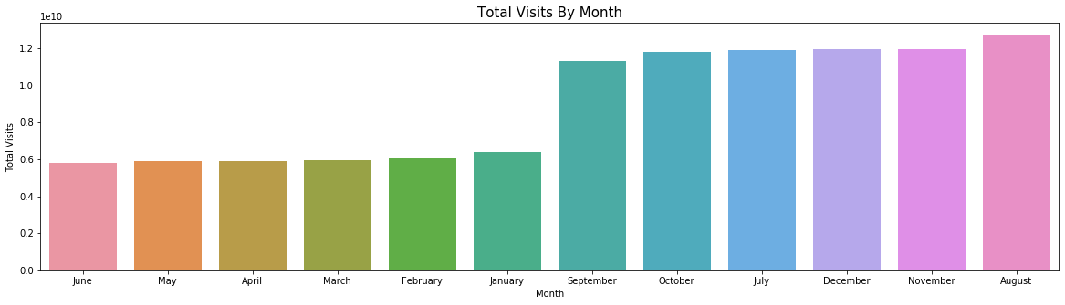

Fig 6. Monthly Visits

In month comparison figure 6, August has the most visits; and the rest months of latter half year gain more visits compared to the first half year.

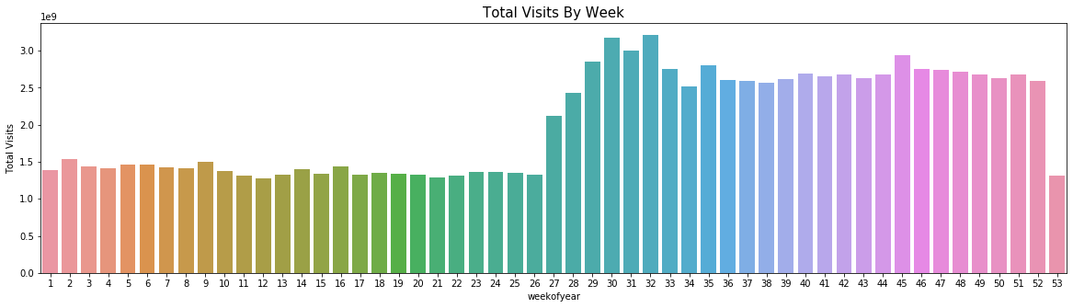

Fig 7. Week of Year Visits

Base on the week of the year visits, the latter half of year attracts more visits compared to the first half of the year.

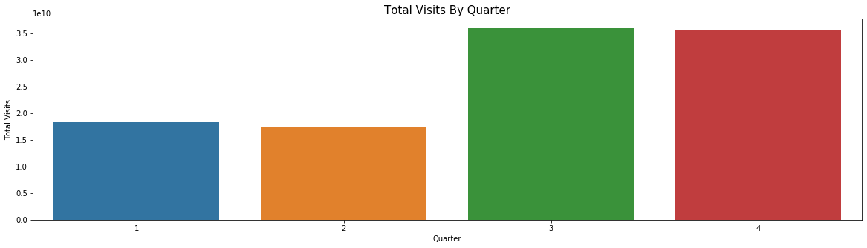

Fig 8. Quarter Visits

It is clear to see that more visits happened in quarter 3 and 4 from figure 8.

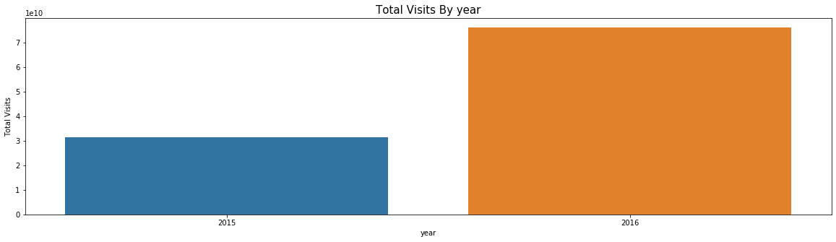

Fig 9. Yearly Visits

In figure 6, there is a dramatic visits increasing in year 2016.